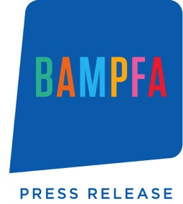

BAMPFA to Present
Hippie Modernism: The Struggle for Utopia
On View February 8–May 21, 2017

Exhibition Celebrates the 50th Anniversary of the Summer of Love by Showcasing Radical Design and Architecture of the Bay Area Counterculture
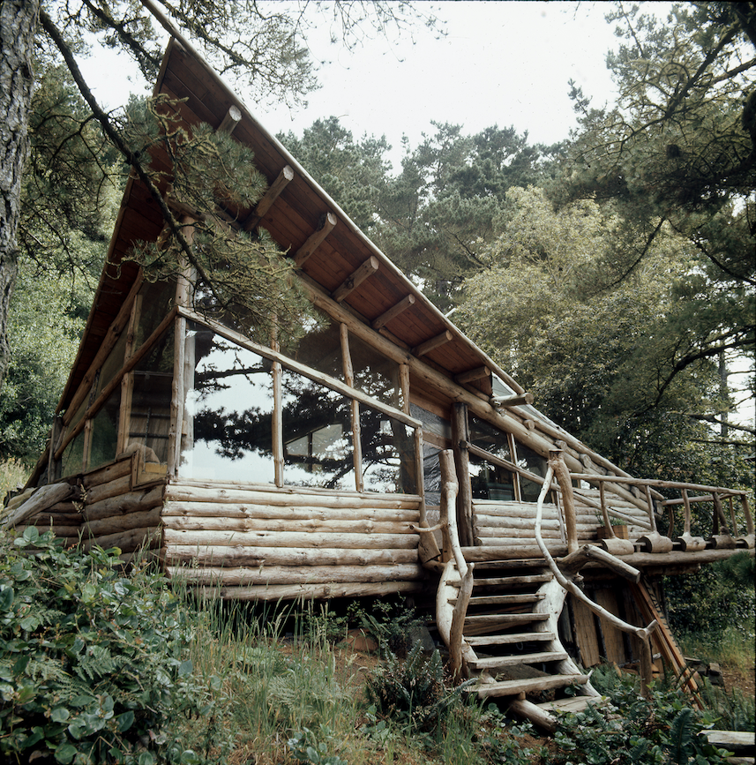

Press Preview: Tuesday, February 7, 2017 at 10am
RSVP to BAMPFA@fitzandco.com

(Berkeley, CA) January 16, 2017—The University of California, Berkeley Art Museum and Pacific Film Archive (BAMPFA) will launch the region-wide celebration of the 50th anniversary of the Summer of Love with Hippie Modernism: The Struggle for Utopia. This major exhibition explores the intersection of the radical art, architecture, and design of the counterculture of the 1960s and early 1970s and the resonance of these innovations today. A traveling exhibition organized by the Walker Art Center and assembled with the assistance of BAMPFA, Hippie Modernism will be on view in Berkeley from February 8 through May 21, 2017. The exhibition will coincide with the first anniversary of BAMPFA’s new Diller Scofidio + Renfro–designed building in downtown Berkeley.

The curators of the Berkeley presentation, BAMPFA Director and Chief Curator Lawrence Rinder and UC Berkeley Associate Professor of Architecture Greg Castillo, have added nearly 75 works to the exhibition, expanding its scope to highlight the key role the Bay Area—and especially Berkeley—played in the counterculture movement. Many artists, architects, and designers in this period were searching for a new kind of utopia as an implicit critique of society; however, in the Bay Area, many hoped to go beyond mere critique to create actual change—technological, political, and ecological—on the streets, in the classroom, and in government policy.

The Berkeley presentation of Hippie Modernism includes a special focus on the transformative design and architecture of Northern California counterculture—ranging from documentation of the hand built houses of Canyon and Sausalito and the Emeryville mudflats anonymous sculpture park to J.B. Blunk’s iconic redwood stools and Gary D. Anderson’s original design for the now ubiquitous recycle symbol from 1970. Additional exhibition highlights include:

- Community Memory, a computerized public bulletin board system established in Berkeley in 1973, making it one of the first-ever digital social networks
- Archival materials from Bay Area protest movements and collectives, including the Indians of All Tribes’ nineteen-month-long occupation of Alcatraz (1969–71) and the gender-bending performances of the Cockettes and the Angels of Light
- Works by Bay Area artists and designers, including Frances Butler, Gordon Ashby, J.B. Blunk, Sonya Rapoport, and Bonnie Ora Sherk
- Posters from the Chicago Women’s Graphics Collective, the Black Panthers, the Mexican-American Liberation Art Front, and the 1970 Gay-In in Griffith Park

For further information, and an expanded press release about the exhibition, visit BAMPFA’s website.

The Berkeley presentation is accompanied by Hippie Modernism: Cinema and Counterculture, 1964–1974, a four-month film series organized by Associate Film Curator Kate MacKay. The series, which will run from February – May 2017, includes documentaries, experimental works, and feature films that explore the progressive social, political, and aesthetic concerns of the era. Highlights include BAMPFA’s newly completed restoration of Steven Arnold’s Luminous Procuress; Haskell Wexler’s Medium Cool; Peter Watkins’s Punishment Park; and Michelangelo Antonioni’s Zabriskie Point. Also central to the film series are works by and about the Berkeley area counterculture, including Elegy to Ecstasy (1964–74), a program from the Bay Area’s famed Canyon Cinema; Jordan Belson: Films Sacred and Profane (1954–77), which features the meditative films of the Bay Area filmmaker; and John Coney's Space is the Place (1974), which was shot in Oakland and stars Sun Ra, and was inspired by a series of lectures Ra gave at UC Berkeley. A full list of films can be found on BAMPFA’s website.

In conjunction with Hippie Modernism, BAMPFA will also present a robust program of public talks and events, including a conversation with Michael Pollan and Simon Sadler on hippie holism, LSD, and promising new uses of psychedelic drugs now emerging from psychotherapeutic research; a series of Hippie Modernism Forums featuring local artists, designers, and scholars; and a free screening of Bob Smeaton’s Festival Express on BAMPFA’s outdoor screen. For a full list of public programs, visit BAMPFA’s website.

The museum has also joined forces with the San Francisco-based firm Goodby Silverstein & Partners to create an innovative augmented reality app, launching in early February. As a companion piece to the exhibit, the app, among other features, will provide a “Love Tour” of the Bay Area, and allow users to release virtual “Love Balloons” with personal messages. This educational guided tour of San Francisco and the East Bay highlights prominent sites of the hippie and counterculture movement.

Support
Hippie Modernism: The Struggle for Utopia is organized by the Walker Art Center in association with BAMPFA. The exhibition was curated by Andrew Blauvelt, director of Cranbrook Art Museum. The BAMPFA presentation is organized by Director and Chief Curator Lawrence Rinder and guest curator Greg Castillo, associate professor of architecture at the University of California, Berkeley.

The exhibition is made possible with support from the Martin and Brown Foundation, the Prospect Creek Foundation, Annette and John Whaley, and Audrey and Zygi Wilf. Support for the exhibition catalog is provided by the Graham Foundation for Advanced Studies in the Fine Arts and a grant from the Andrew W. Mellon Foundation in support of Walker Art Center publications. The BAMPFA presentation is made possible with generous support from Coleman Fung, Frances Hellman and Warren Breslau, Nion McEvoy and Leslie Berriman, Goodby Silverstein & Partners, Adobe, Chip Conley Foundation, Beth Rudin DeWoody, Carla and David Crane, Donna and Gary Freedman, Gyöngy Laky and Thomas Layton, Greg Castillo and Gary Brown, Chris Desser and Kirk Marckwald, and Joyce and Mark Hulbert.

Above
Barry Shapiro: Waite Home, Canyon, California, c. 1971; digital image from slide; Barry Shapiro photograph archive, BANC PIC 2016.003, The Bancroft Library, University of California, Berkeley.

Visitor Information
Address
2155 Center Street Berkeley, CA 94704
Hours
Wednesdays, Thursdays, and Sundays, 11 a.m. to 7 p.m.
Fridays and Saturdays, 11 a.m. to 9 p.m.

Information
bampfa.org
(510) 642-0808

Gallery Admission
$12 general admission
$10 Non-Berkeley students, disabled, 65+
Free for BAMPFA members; UC Berkeley students, faculty, staff, and retirees; 18 & under + one adult
Free First Thursdays: Free gallery admission on the first Thursday of each month

Social Media
facebook.com/bampfa
twitter.com/bampfa
instagram.com/bampfa
Hashtag: #HippieModernism #BAMPFA

About BAMPFA
Internationally recognized for its art and film programming, the UC Berkeley Art Museum and Pacific Film Archive (BAMPFA) is a platform for cultural experiences that transform individuals, engage communities, and advance the local, national, and global discourse on art and film. Founded in 1963, BAMPFA is UC Berkeley’s primary visual arts venue with its screenings of some 450 films and presentations of up to twenty exhibitions annually. BAMPFA’s mission is to inspire the imagination and ignite critical dialogue through art and film.

The institution’s collection of over 19,000 works of art dates from 3000 BCE to the present day and includes important holdings of Neolithic Chinese ceramics, Ming and Qing Dynasty Chinese painting, Old Master works on paper, Italian Baroque painting, early American painting, Abstract Expressionist painting, contemporary photography, and Conceptual art. BAMPFA’s collection also includes over 17,500 films and videos, including the largest collection of Japanese cinema outside of Japan, impressive holdings of Soviet cinema, West Coast avant-garde film, seminal video art, as well as hundreds of thousands of articles, reviews, posters, and other ephemera related to the history of film—many of which are digitally scanned and accessible online.

Media Contacts
National Inquiries
Ellen Watkins, FITZ & CO | 646-589-0929 | ewatkins@fitzandco.com

Meg Blackburn, FITZ & CO | 212-620-7390 | mblackburn@fitzandco.com

Bay Area Film Inquiries
Karen Larsen, Larsen Associates | 415-957-1205| karen@larsenassc.com

